**e-Education**

**Project Members:**

Venkata Vamsi Siva Krishna Vura

Sandeep Keshetti

Venkatesh Kadiyala

**1. Introduction**

In modern world most of the data (alpha-numeric information) is collected and stored in the form of writing and in print. Thus, most knowledge and learning construction takes place today through the symbolic learning channel, which makes the ability to read and write. However, about a third of the global population is illiterate. Visual literacy has been defined as the “ability of people to understand and know visual information”. “Visual literacy came through the idea of pictures can be seen and that meaning can be communicated through the process of reading.”

**2. Project Goal and Objectives**

**Overall goal**

Computer-Based Trainings (CBTs) will be a good solution to printed learning materials since rich media, including images, videos, messages or animations, can easily be used to enhance the learning. Another advantage of computer based training is that they can be easily distributed to a large number of people at a relatively low cost once the initial development is completed. Typically the creation of good CBTs requires large number of resources.

**Problem Statement**

The software for developing CBTs (such as Flash or Adobe Director) is often more complex than a subject matter expert or teacher is able to use. Apart from this, the lack of human interaction can limit both the type of content that can be presented as well as the type of assessment that can be performed. Now a day's most of the organizations are beginning to use smaller CBT/WBT activities as part of a broader online learning program which may include online discussion or other interactive elements.

It is estimated that there are about 700 million adult illiterates in the world today. They represent about 44 per cent of the total population 15 years old and over. Almost half of all the countries and territories (97 out of 198) are believed to have 50 per cent or more illiteracy among their adult population. About 30% 0f all the countries, there are at least a million adult illiterates in each country. By far the larger portion of the world‘s illiterates are to be found in certain parts Asia and Africa. However, the problem of illiteracy is certainly not confined to these regions. At least 1 country in the Western Hemisphere has more than 15 million adult illiterates, another has over 5 million, and 8 other countries have each I million or more.

**Significance**

Computer based tests presents an innovative idea in the field of learning and provides a great way to gaining the knowledge. By using the online services by the wide range of electronic learning solutions such as Web-based courseware, online alphabets learning, and online words speaking using audio and visually. Illiteracy people easily learn the how to read and writes. It is helps to decrease the illiteracy.

**3. Project Background and Related Work**

The manual system is costly and time consuming. Information is not available in methodical manner. Sometimes system doesn’t provide the updated information. It generates more hassle for the learner. Searching for the desired content is quite complex. Information is in distorted manner. Higher degree distortion creates confusion in mind.

**4. Proposed System**

**4.1. Requirement Specification**

**Functional Requirements**

**Working with Remote Instruments**

Through a browser interface, makes it possible for students around the world can use this application. This application build in web based 3-tier architecture. The data of the user can be stored in remote database.

**User**

Here user is end user of the application. He can use this application remotely that means from anywhere he can use this application. He can login into his own space after registration. He can learn the content with the help of audio. After he can check his performance by online tests.

**Non-functional Requirements**

The Online Learning system shall be multi-tier, web based solution (have web based front-end for users and for system administrative functions), with the centralized database.

The application will be architected and designed using the principles of Service Oriented Architecture (SOA) The System will be compatible with all leading web browsers especially with Microsoft Internet explorer and/or Mozilla Firefox etc.,

The learning system that is going to create is very simple it has so many drop box menus, scrolling tabs and selection buttons more than that it is also more useful to illiterate because they can easily use such type of tools.

**Technologically and Architectural requirements**

**Hardware Requirements:**

* System : Intel core 2 Duo
* Hard Disk : 40 GB.
* Ram : 512 Mb.

**Software Requirements:**

* Operating system : Windows XP.
* Coding Language : JAVA
* Data Base : MySQL

**4.2 Framework Specification**

**Assumptions and Principles**

This section considers the way in which we can map from the underlying assumptions about the nature of learning to the design of learning environments. This is the crucial stage in the design process: where the learning theory is unpacked into a detailed pedagogical approach. We can summaries the design implications of our three theoretical strands as follows:

The associative view emphasizes

* Routines of organized activity
* Clear goals and feedback
* Individualized pathways and routines – matched to the individual’s prior performance

**System Architecture Diagram**

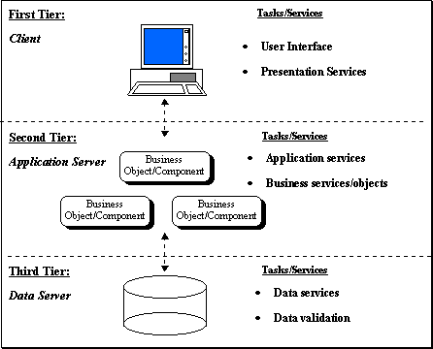

**Presentation service**

Presentation services refers to part of the application which presents the data to user. In addition, it also provides for the mechanisms the way user will interact with the application data. More simply, presentation service defines and interacts with the user interface. The presentation of the data in this generally not contain any validation rules. Delphi Client and Server Suite's Rapid Application Development (RAD) approach for development of application and component architecture allows the developer to easily assemble the presentation layer and move quickly from prototype to the production.

**Application services**

Application servers provide other necessary functional requirements for the application.

**Data services**

'Data services' provide access to the data independent of their location. The data can come from SQL RDBMS systems, or proprietary data access systems. The data services provide a standard interface for accessing data.

**4.3 System Specification**

**New Services to be built**

**Words are describe with image and audio**

Every image in this application will explain with text and sound. Image will used to describe the word and sound will used to how to pronounce the word.

**Class Diagram for LOGIN page**

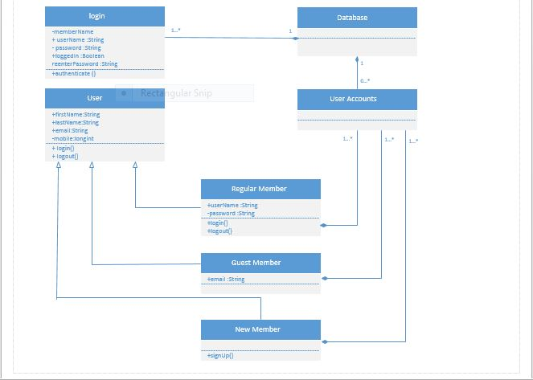

**Sequence Diagram for LOGIN Page**

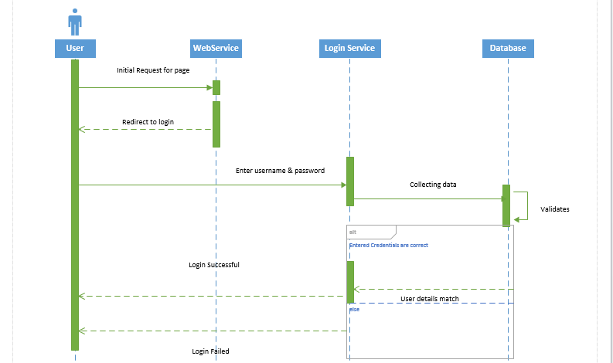

**Class Diagram For e-Education**

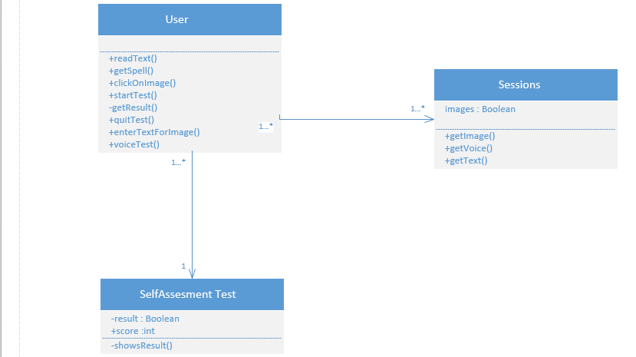

**Sequence Diagram For e-Education**

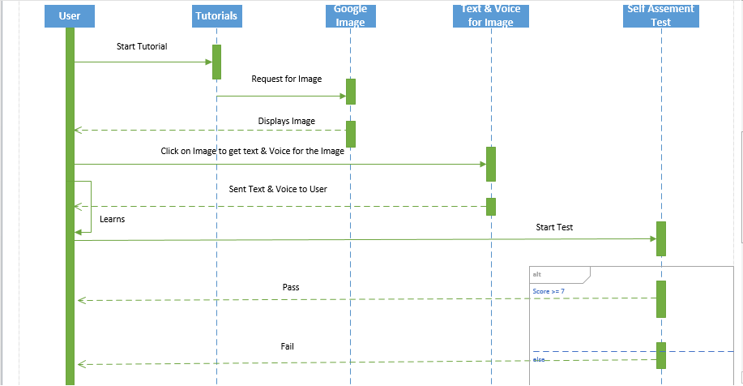

**Service Specification**

**Operational description**

In this service the function takes a image from user and return the text and audio of the word.

**Input/output for services**

In this service the function takes a image as input and return text and audio related of the word as output.

**5.Bibliography**

1.www.oilennium.com › [eLearning Demos](http://www.oilennium.com/demos/)

2.<http://edn.embarcadero.com/bg/article/103>

3.<http://www.codeproject.com/Articles/22218/An-API-for-Yahoo-Image-Search>

4.<http://developer.android.com/reference/android/speech/RecognizerIntent.html>

5.<http://www.newmedialab.com.au/managed_e-learning.html>

**Different Phases of the project "e-Education"**

Writing code in Scheme in java programming language. In this stage we are developing the GUI, business logic and data base logic. While writing the code only we are doing the unit testing.

The Coding is again divided into 4 sub stages

**1.** In this stage we are writing the code for GUI. I.e. design of registration page, login page by using html and jsp. Whatever the details entered by user in registration page will be stored in the data base. For that we are writing business logic and database logic and validating the entered data by using JavaScript .I am using backend as MySQL.

2.The registered users login to the website. Here we are checking the whether the user entered username and password is available in database or not by writing the business logic. If the user entered data is correct the he will get the user’s home page. In user home page we are providing images, blow the images we are providing text (it explains about the image) and audio for that image. In this stage we are writing the code for the user homepage

**3.** In this stage we are maintain sessions for user login. Because after five sessions has to move to matching. So sessions are important. In this stage we write the code for session management. After completion of five sessions the user will get the matching .i.e. one side images and other side spellings related to the images will be there. In this stage we write the code for matching. After matching he will get the result, this means how many are correct.

**4.** In this stage we are testing the code. Here we are checking the code what we written is working properly or not. Some of the examples.

1. Checking it is giving the user home page for valid user name and password or not.

2. Checking whether it is matching after five sessions or not.

SCRUM DO PROJECT:

